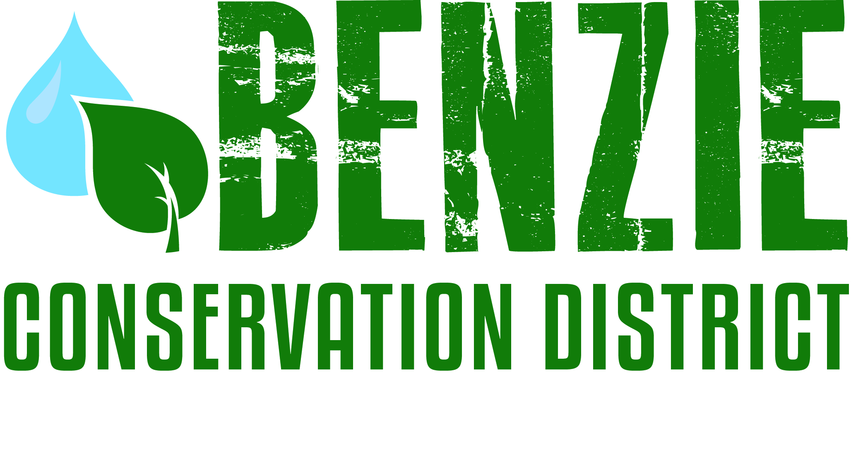
Benzie Conservation District
280 S. Benzie Blvd., P.O. Box 408
Beulah, MI 49617
231-882-4391
www.benziecd.org benziecd@benziecd.org
Benzie Watersheds Coalition Meeting Agenda ~ DRAFT
Wednesday May 29, 2013
Benzonia Township Hall, 3:00 P.M. – 5:00 P.M.

Welcome and Introductions: Tad Peacock 3:00

Topics:
- Updates from summer season All 3:05

2. Water quality monitoring Mike Jones 3:45
- Upcoming water sampling for Upper & Lower Herring
And Crystal Lake - others?
- Other monitoring efforts, New hydrolab sondes
- Hydrolab Training - who’s interested?

2. Events/Education Mike/Tad/All 4:00
- Waters of Benzie Educational Tour Series: next up is Bass Lake on June 7 plus
a report on past events
- Shoreline workshop on July 19; shoreline project tour on July 26
- Nature Core

3. Projects Mike/Tad 4:15
- BC Stewardship Checklist - update
- MiCorps VSMP Grant - update
- Seawall removals/shoreline projects:
- Wetland construction update at the new Almira Township Park on Ann Lake.
- Betsie River/Crystal Lake Management Plan Ed Hoogterp

4. Invasive Species Katie G/Jill F 4:30
- Merger of Cooperative Weed Management Area and Invasive Species Network
- Priority species

5. Moving forward – what’s next? All 4:45

Next meeting date: All 4:55

Adjourn 5:00

