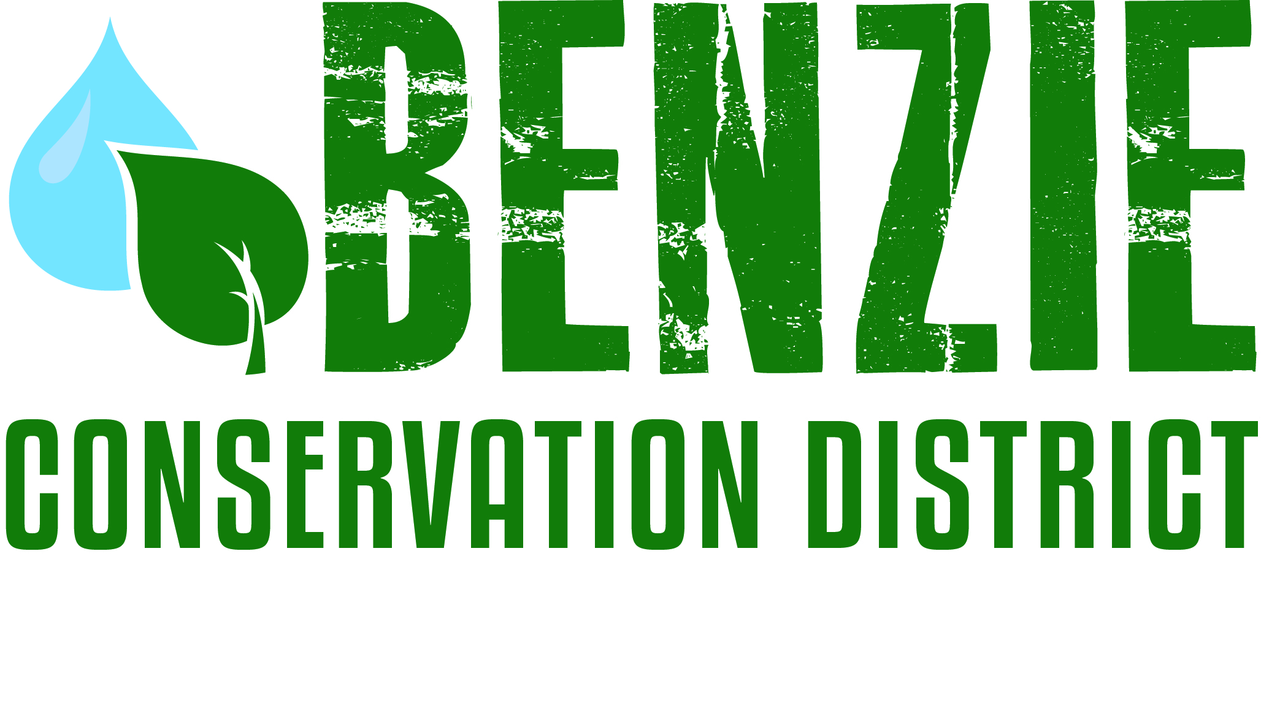
Benzie Conservation District
280 S. Benzie Blvd., P.O. Box 408
Beulah, MI 49617
231-882-4391
www.benziecd.org benziecd@benziecd.org
Benzie Watersheds Coalition Meeting Agenda
Tuesday, May 19, 2015
Benzonia Township Hall, 3:00 pm – 5:00 pm

Welcome and Introductions: Tad Peacock 3:00

Topics:
- Member updates All 3:05
Short oral update on your group’s plans for the year.

- Summer Water Monitoring Mike/All 3:40
Overview of available parameters, and updates on groups doing additional monitoring.

- Old Business Mike/Tad/All 4:00
- VSMP Update-results until now Mike
- Invasive species update Katie G.
- Betsie River/Crystal Lake Management Plan Ed Hoogterp
- Herring Lakes Management Plan/SAW Grant Tad
- Platte Management Plan/Approved Mike/Wil

4. New Business/Projects Mike/Tad 4:45
a) Swimmer’s Itch Study
b) Crowd Hydrology Permit
c) Upcoming events:
May 9: BCD Volunteer Stream Monitoring Spring Collection Event
May 22, 9 am: Lower Herring Lake Water Tour. DNR access site.
June 6: Farms of Benzie-Harris Farms. North of Honor, featuring asparagus.
June 13: 4th Annual Betsie River Clean Sweep.
July 13: Upper Platte River Debris Clean-up.
July 15: Farms of Benzie-Lutz Farms. Dry Hill property, featuring cherries.
July 18, 9 am: Pearl Lake Water Tour. Wagner Road access site.
July 30, 9 am: Pickeral Creek/Twin Lakes Water Tour. Grass Lake Campground river access.
August 15, 9 am: Upper Platte River Water Tour. Veteran’s Memorial Campground river access.

Next meeting date: All 4:55

Adjourn 5:00

